Sponsored by Oscar Pet Foods
BRINKLOW FESTIVAL
FUN DOG SHOW
Run by
Nuneaton Dog Training Club Demonstration Team
VENUE
Brinklow Playing Fields, Barr Lane, Brinklow, CV23 0LU

27th August 2022
Classes start at 1pm entries on the day from 12 noon
Entries £2 per class or 3 entries for £5
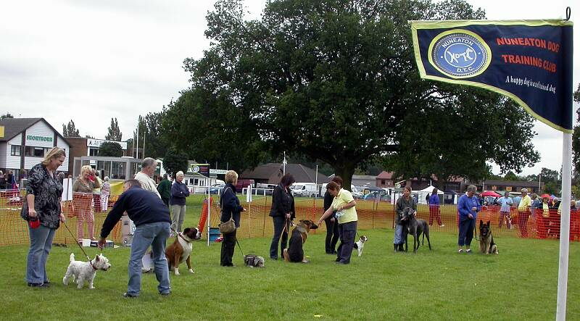
Dog Show Classes as follows:
- Puppy (up to 12 months
- Best Pure-breed
- Best Cross-breed
- Prettiest Bitch
- Handsomest Dog
- Best Rescue/Re-homed Dog or Bitch
- Dog with the Waggiest Tail
- Dog in Best Condition
- Dog the Judge would most like to take home
- Best Trick or Obedience moves.
(Classes will be judged by the Nuneaton Dog Training Club Demo Team)
ROSETTES IN EACH CLASS TO 5TH PLACE
+ RIS & RBIS ROSETTES
FOR FURTHER DETAILS CONTACT GLORIA BONNELL
ON 07762110330 AFTER 9AM OR BEFORE 6PM PLEASE

