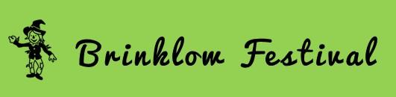
Entry form
This year we want Scarecrows on display for a week
Friday August 26th – Friday September 2nd 2022
NAME:_____________________________________
Address: ___________________________________
Tel No./e-mail_______________________________
Name of scarecrow(s):_____________________________
Entry Fee £2 ___
Closing Date for Scarecrow entries: Saturday 20th August 2022.
Please submit entry forms enclosing the £2 entry fee at the Brinklow PO and Newsagents, or 24 Colledge Close.
For queries please visit brinklowfestival@gmail.com
Guest Scarecrows are welcomed and can be positioned in the Guest Field next to St John’s church, opposite The Crescent Green, on Friday August 26th.
All guest Scarecrows must be removed by 6pm on Friday September 2nd by the owners.

First Prize - £50, Second Prize - £30, Third Prize - £20.
People’s choice - £30.
Judging will take place on the morning of Saturday 27th August and winners announced at 4p.m.
Votes for the People’s choice will be counted and the winner announced Friday September 2nd.

